PUKAPUKA OCTOBER TO DECEMBER 2025 QUARTERLY REPORT

1. ICI/PUKAPUKA-NASSAU WATER CATCHMENT PROJECT
- This was a major and comprehensive water project for Pukapuka-Nassau culminating in sufficient leftover building material to build 5 more water tanks and this would be the absolute completion of the project.
- The allocation for the tanks are as follows;
1 x SDA Church 1 x Catholic Church
1 x CICC Church 2 x Cyclone Centre
- The SDA and Catholic Churches have already had their tanks built and reported in previous quarterly reports.
- This report will focus on the 3 remaining tanks
- The work was undertaken by our Government workers with help from the Community at large and various Community groups providing extra man-power and meals.

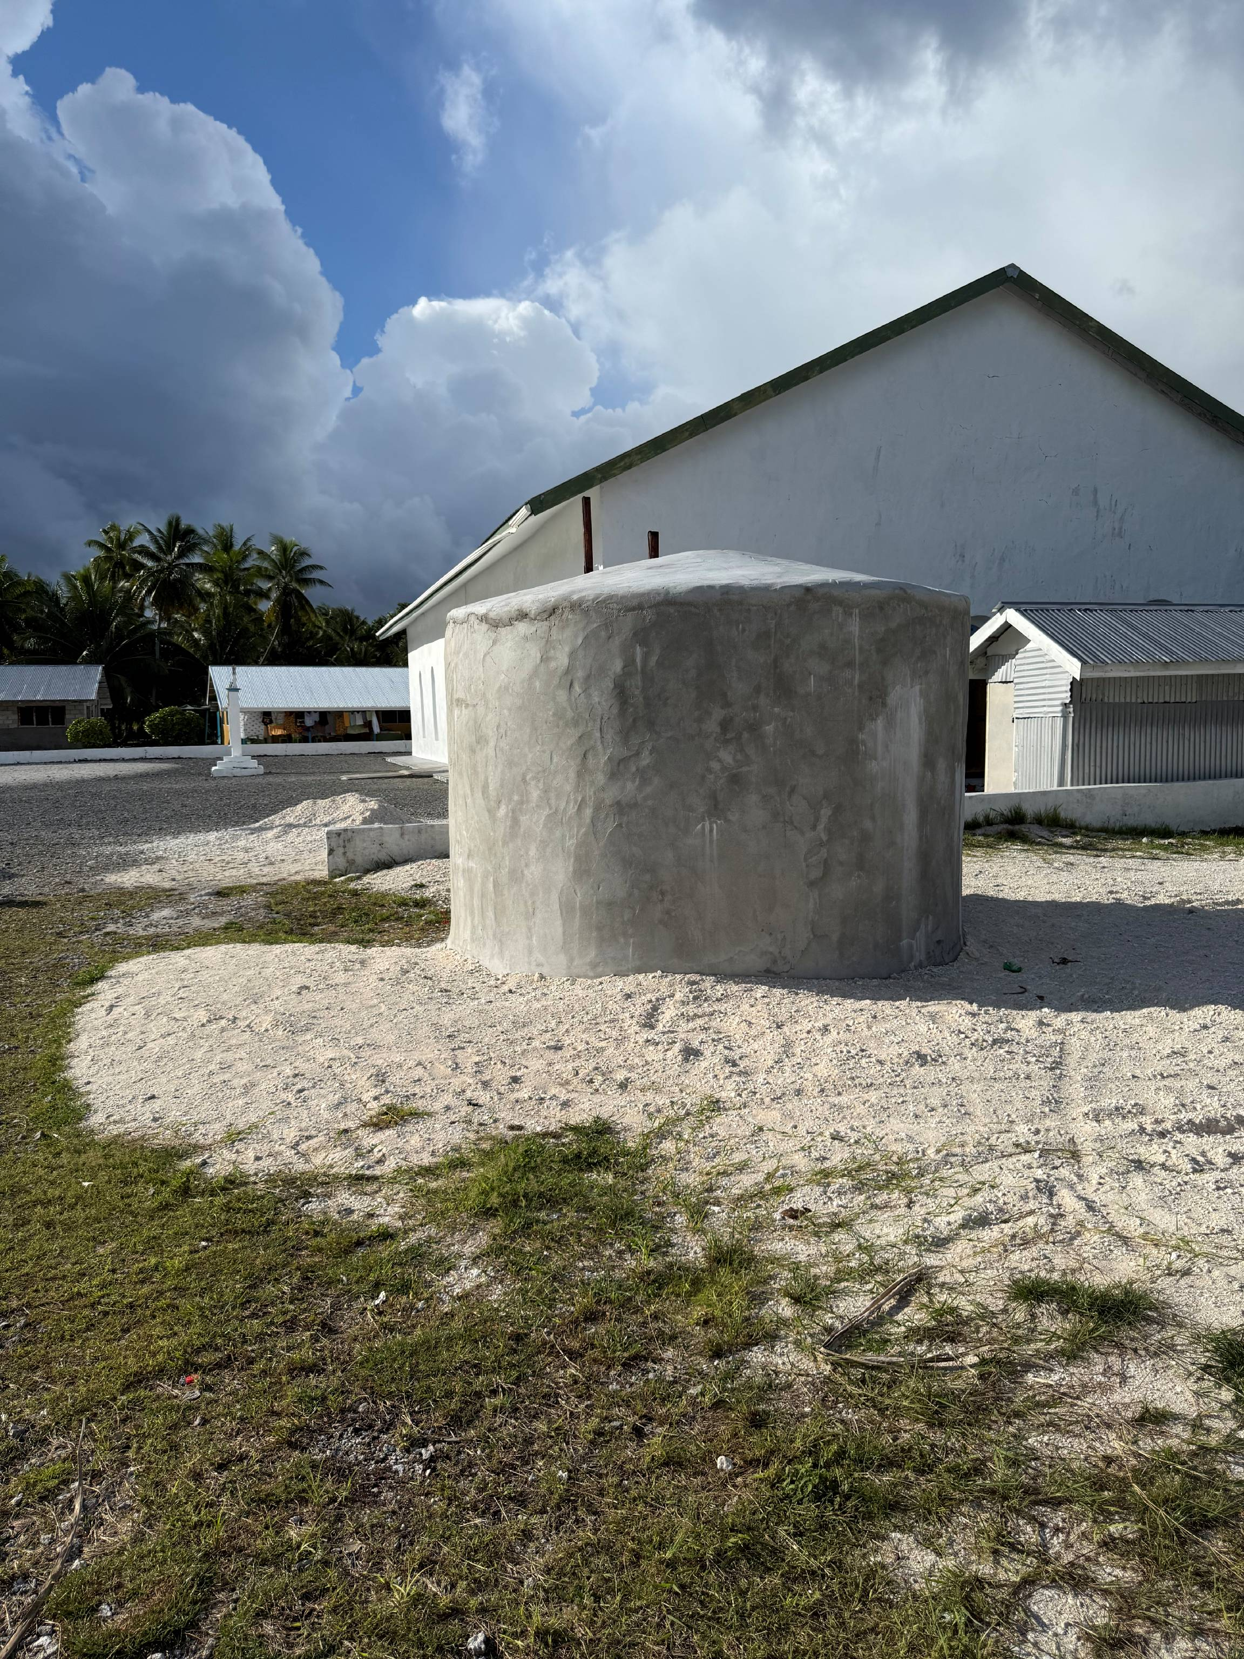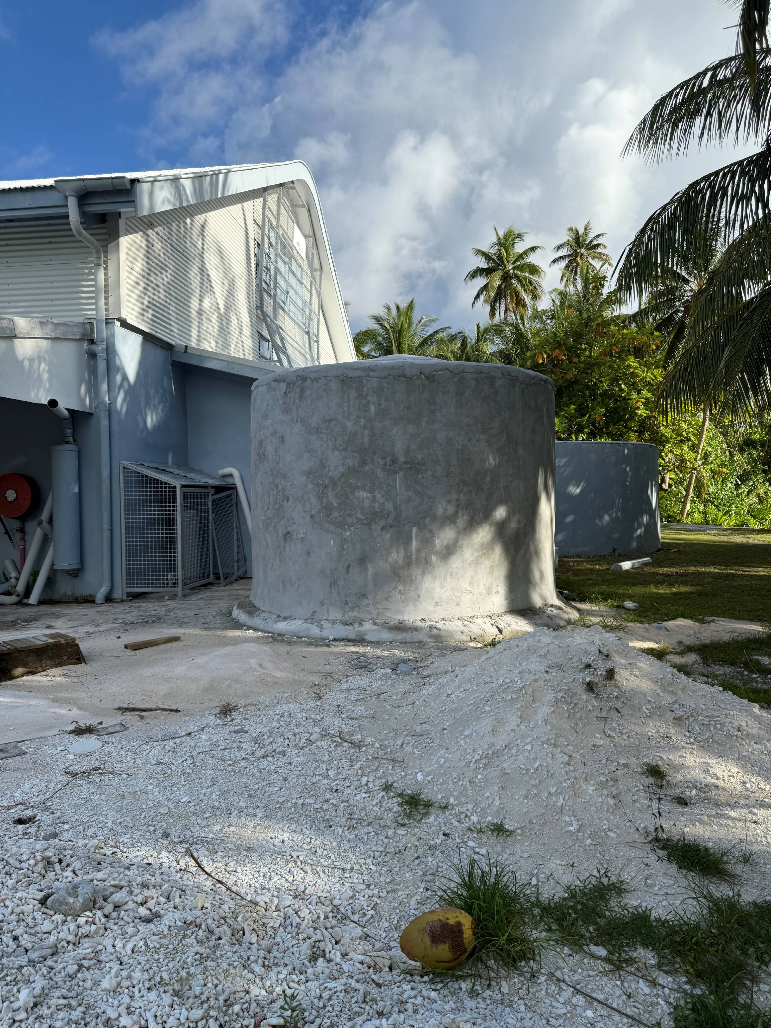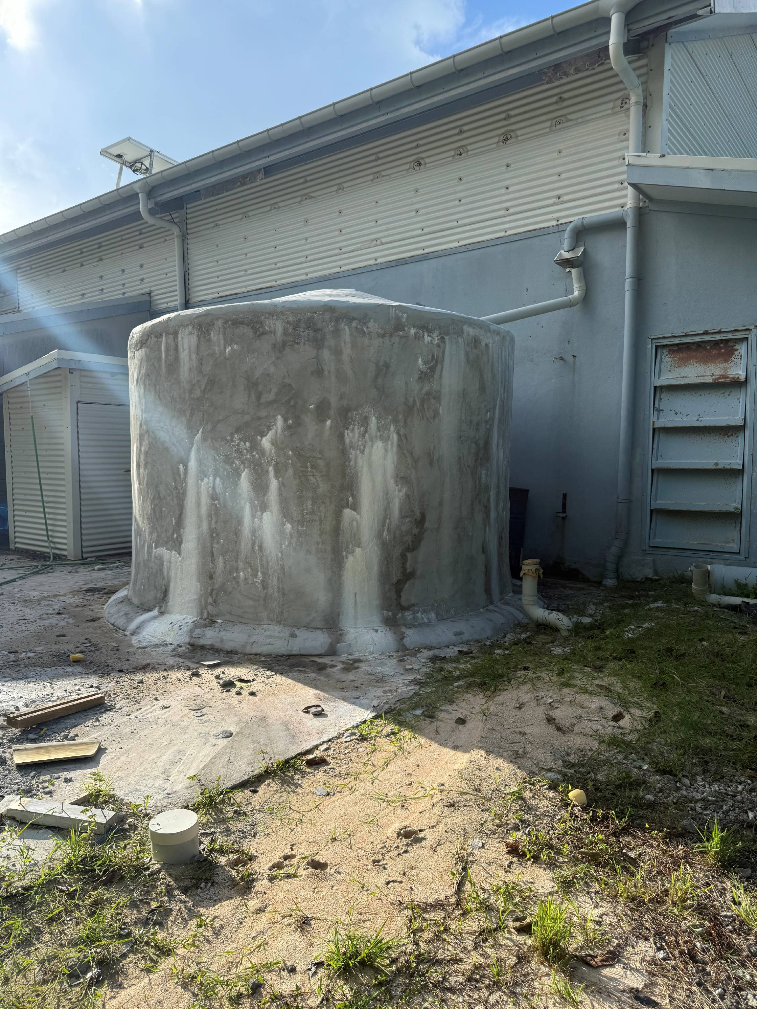

2. FINALLY!!! OUT WITH THE OLD AND IN WITH THE NEW

- YEAH!!! Ngake Meeting House had finally had its old seats replaced with new ones.
- I made the suggestion a several years ago, during one of our fortnightly “changing-of-the-guard” meetings to have these heavy seat benches replaced due to their terrible state of wear and tear. It was already at a stage where it was unsafe to sit on one and to the point that someone was more likely than not liable to get hurt.
- So, it took 2days for the TawaNgake men to build 24 new bench seats and 10 minutes to throw out the old ones and replace with the new ones. These seats are mostly 2.5 meter long
and painted red, the TawaNgake village colour.

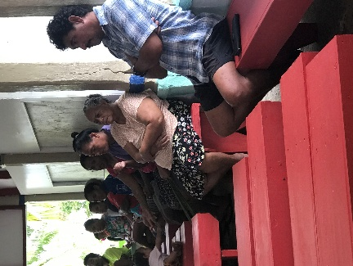
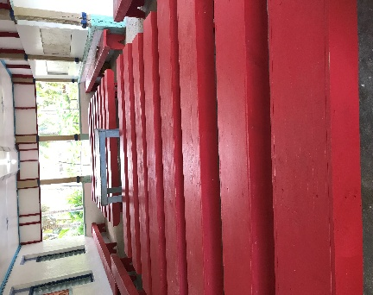
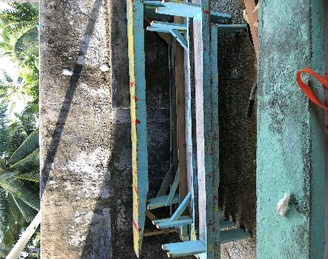

- The funding for the purchase of the timber, nails and paint was provided by the Ngake Village CICC Ekalesia as proprietors/owners of the building.

3. CHRISTMAS, NEW YEAR FESTIVE SEASON AND ANNUAL SPORTS

- On the 1st of November each year the Pukapuka CICC Ekalesia Executive and the Pukapuka Sports Committee members meet to deliberate on the Christmas and New Year festivities, as well as set the program for the upcoming Pukapuka Annual Sports.
- The meeting covers the following events;
- Christmas Eve,
- Christmas Day,
- Boxing Day (the beginning of the Annual Sports),
- New Year’s Eve and
- New Year’s Day
- This group also determines the number and types of sports to include in each year’s competition (including traditional sports).
- The Pukapuka Sports Committee members are elected 4 from each of the 3 Villages. They will take back and divulge all the information from the meeting to their respective villages.

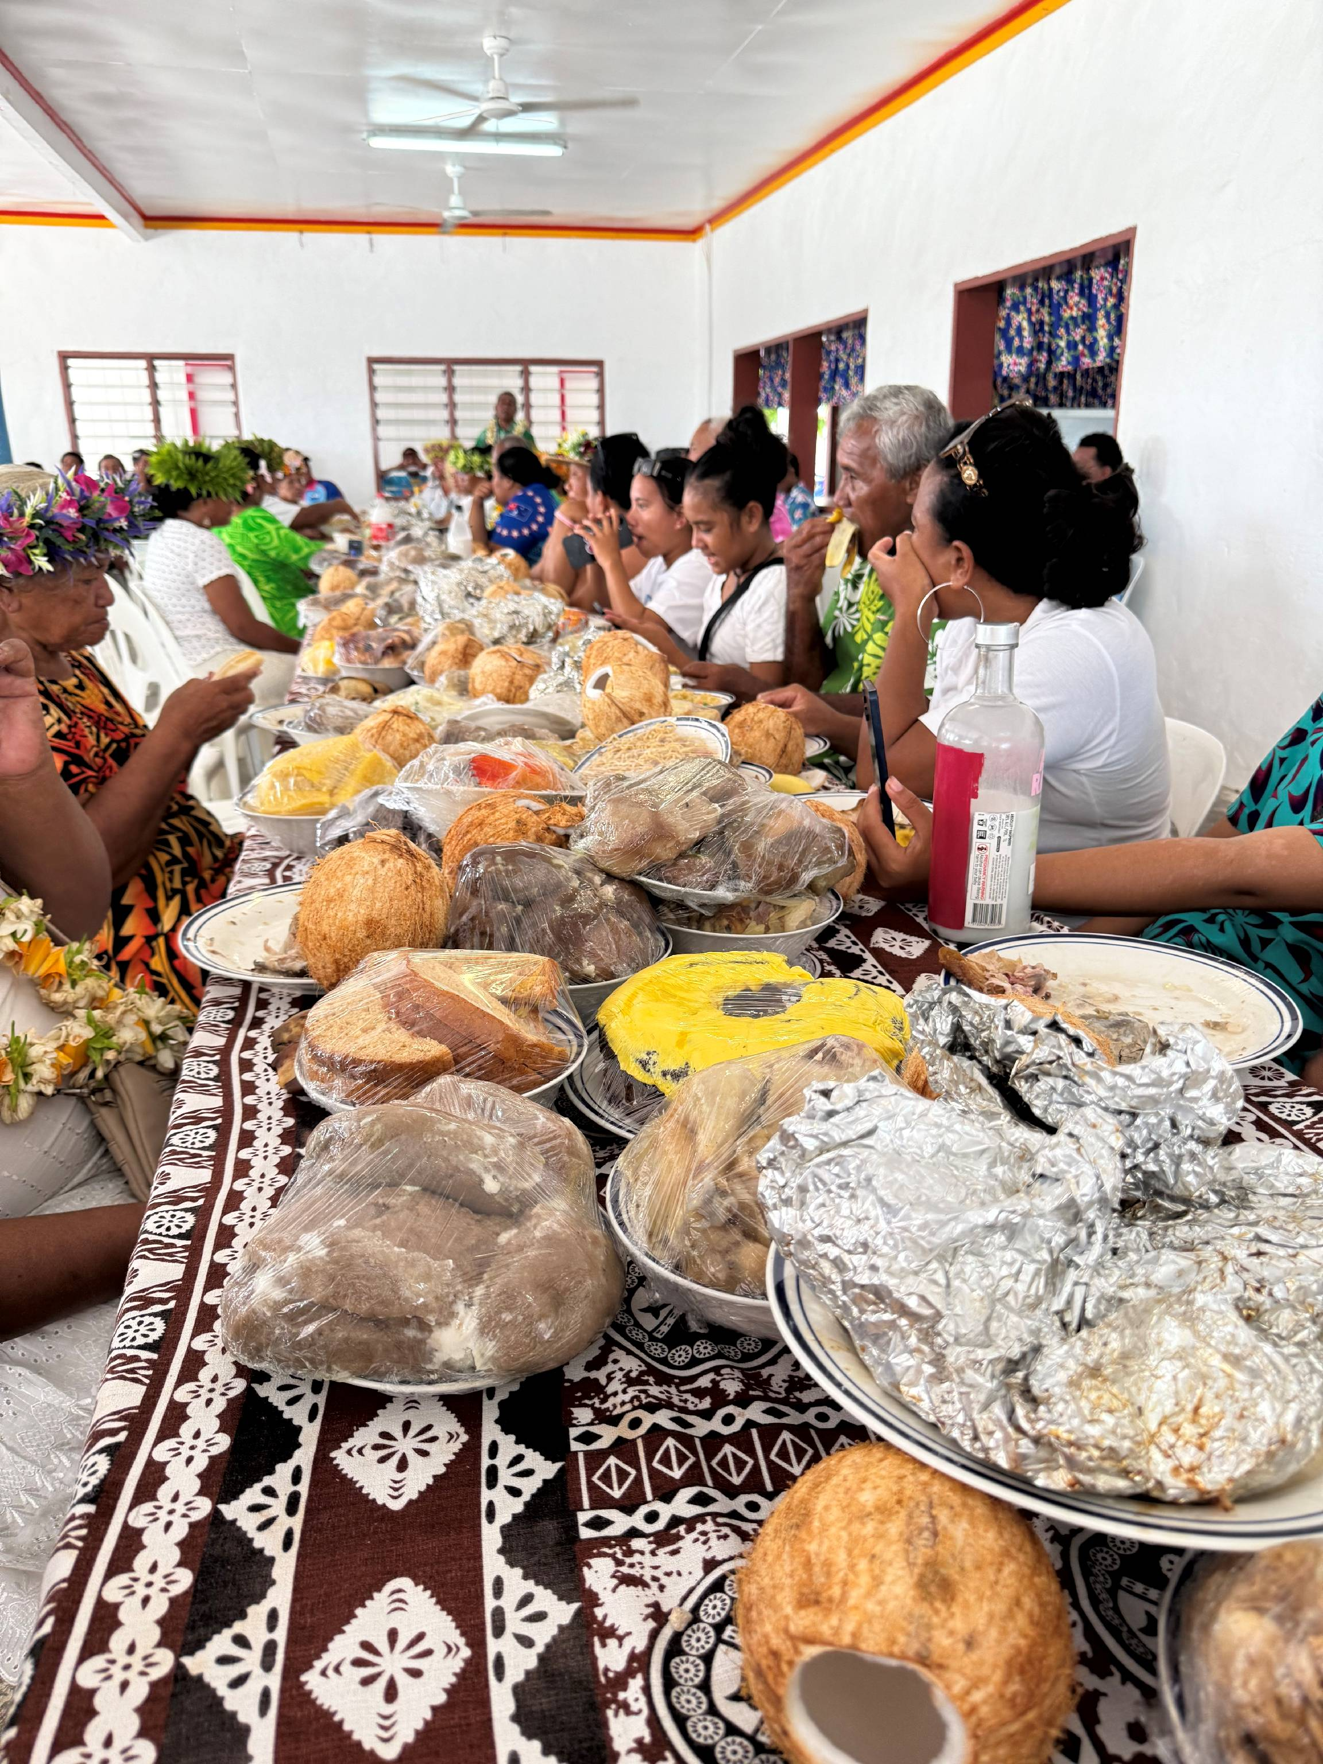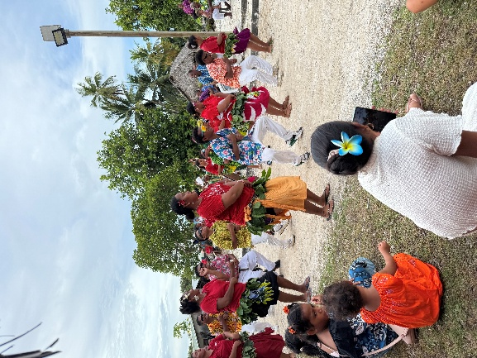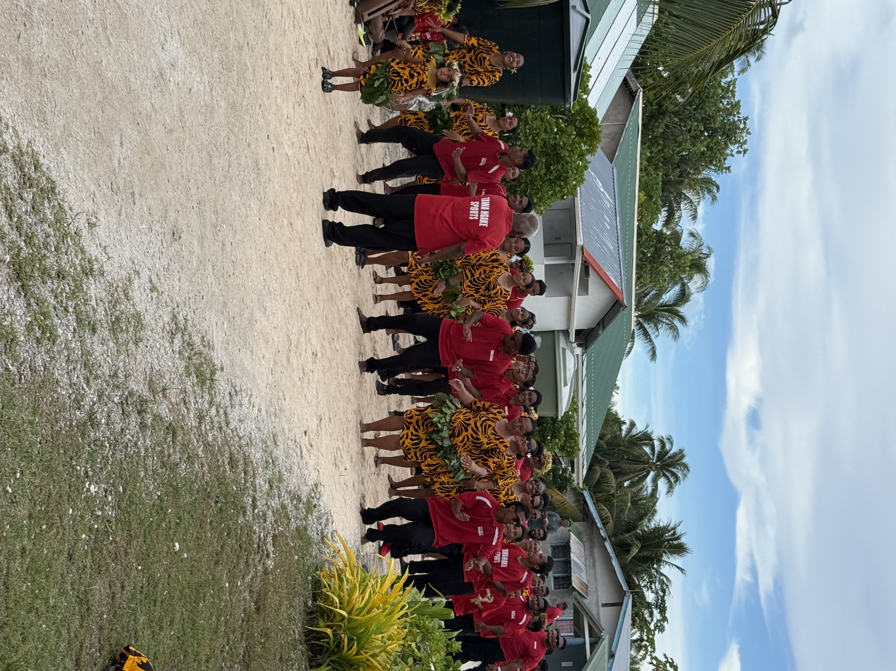

4. CEMETERY CLEANING – Noo Yolonga

- The word Yolonga, in essence means, the place where one is to be interred or buried. Everyone is earmarked to be buried at either one of the major Village Cemetery plots of land or the lesser ones called “wakavae”. All the 3 Villages have them. It is Pukapukan custom that one’s place of burial is determined through patrilineal descent lines and not matrilineal. Meaning through your father or grandfather’s line or mother’s father’s line.
- Unfortunately, in due time, these cemeteries and plots of land are overrun by bush, shrubs and weeds.
- The Aronga Mana (Island Chiefs) issued an Island-wide directive under their authority setting aside 1 month of each year for the Villages to clean all cemeteries. In the past a period of 4 weeks was set around June or July. Nowadays, this has been split into 2 weekly periods, twice yearly. One in April and the other around October. This lightens the work load from 12 months of overgrowth to be cleared to 6 months. Other than the cemetery-clearing work, sporting and fishing contest between the villages are also permitted with feasting throughout the duration of the clean-up.

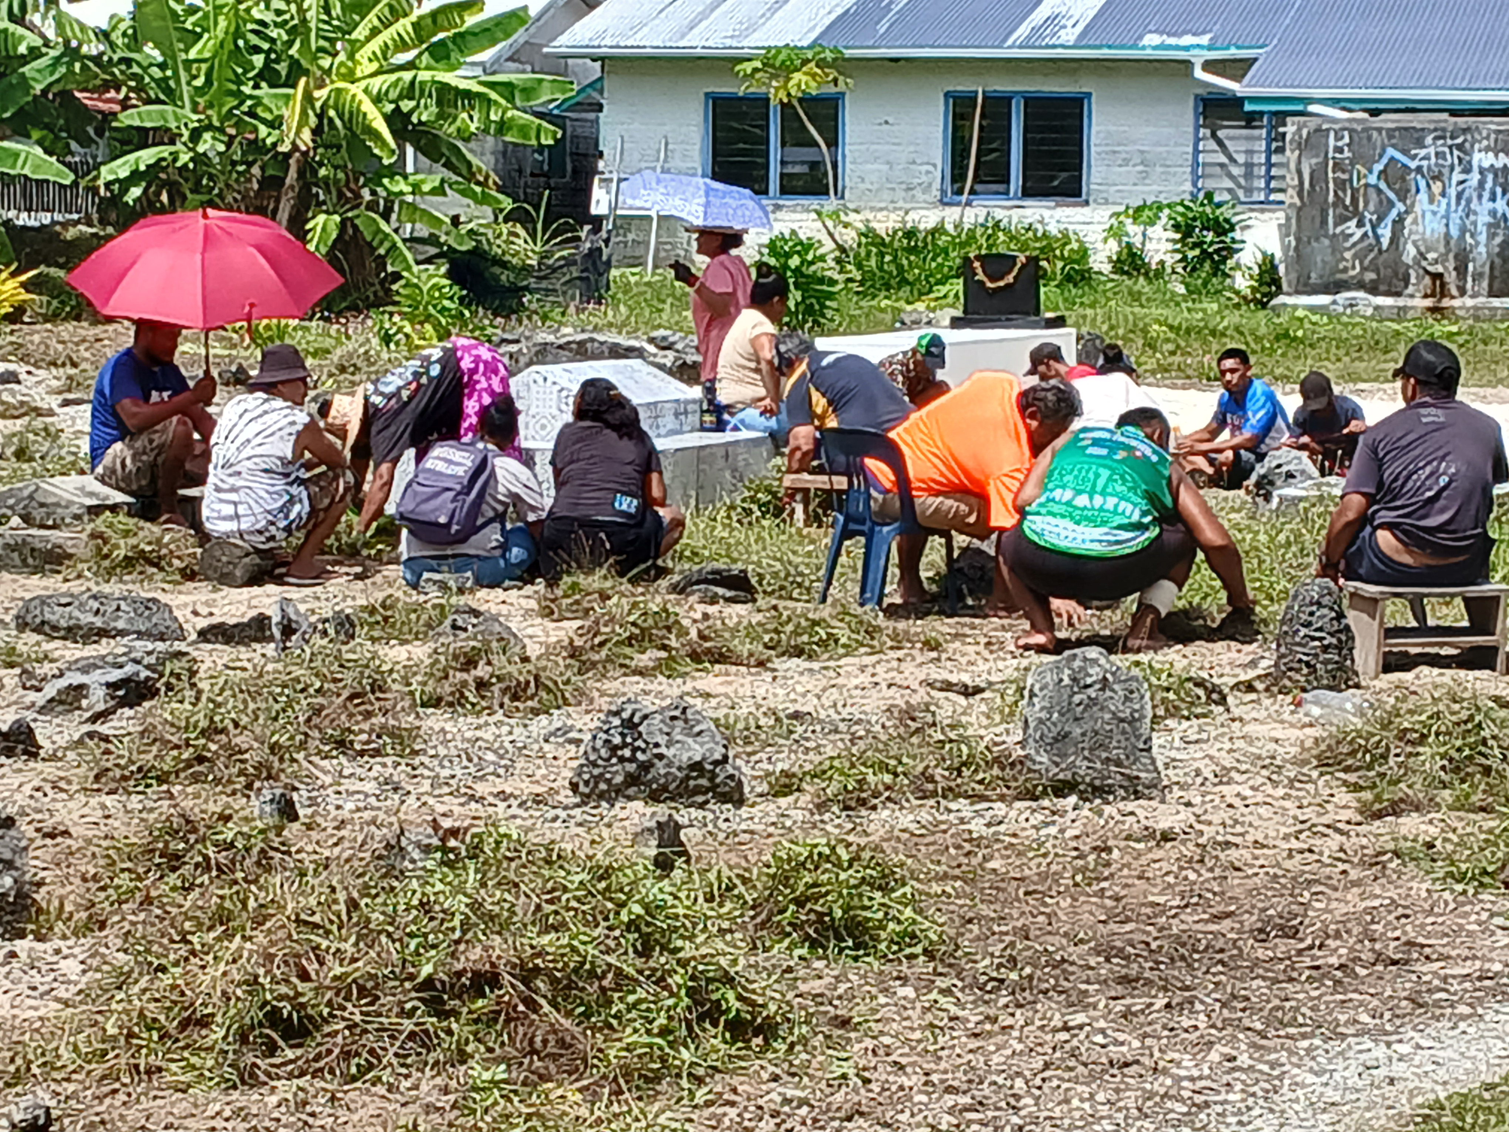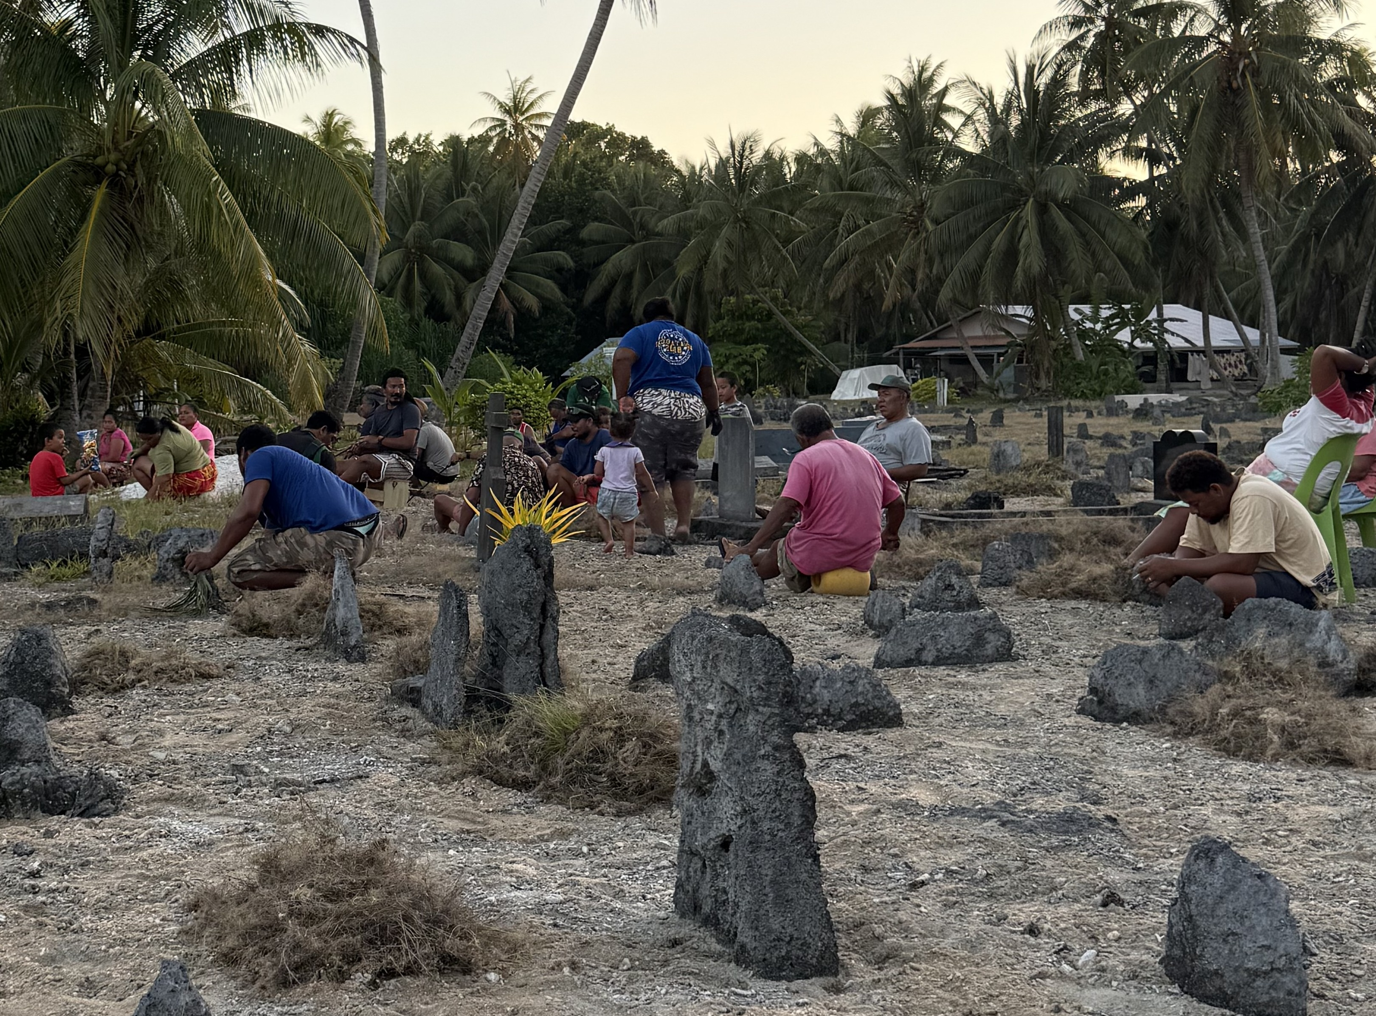

5. TARAMEA – CROWN OF THORNS CLEAN UP OPERATION

- The Island Council instigated another crown of thorns clean-up operation on the reef and lagoon on 4 November. This coincided with Teina Rongo’s visit to the Island to do some research in the lagoon. He and his team were only too happy to participate in the clean-up
- A week later Jackie Rongo joined her husband. In her spare time, Jackie offered volleyball coaching tips to the Pukapukan youth. When asked how her visit was going? She replied, she was actually thoroughly enjoying it, especially her time spent with the young people, saying “...for me, this is volleyball heaven…”

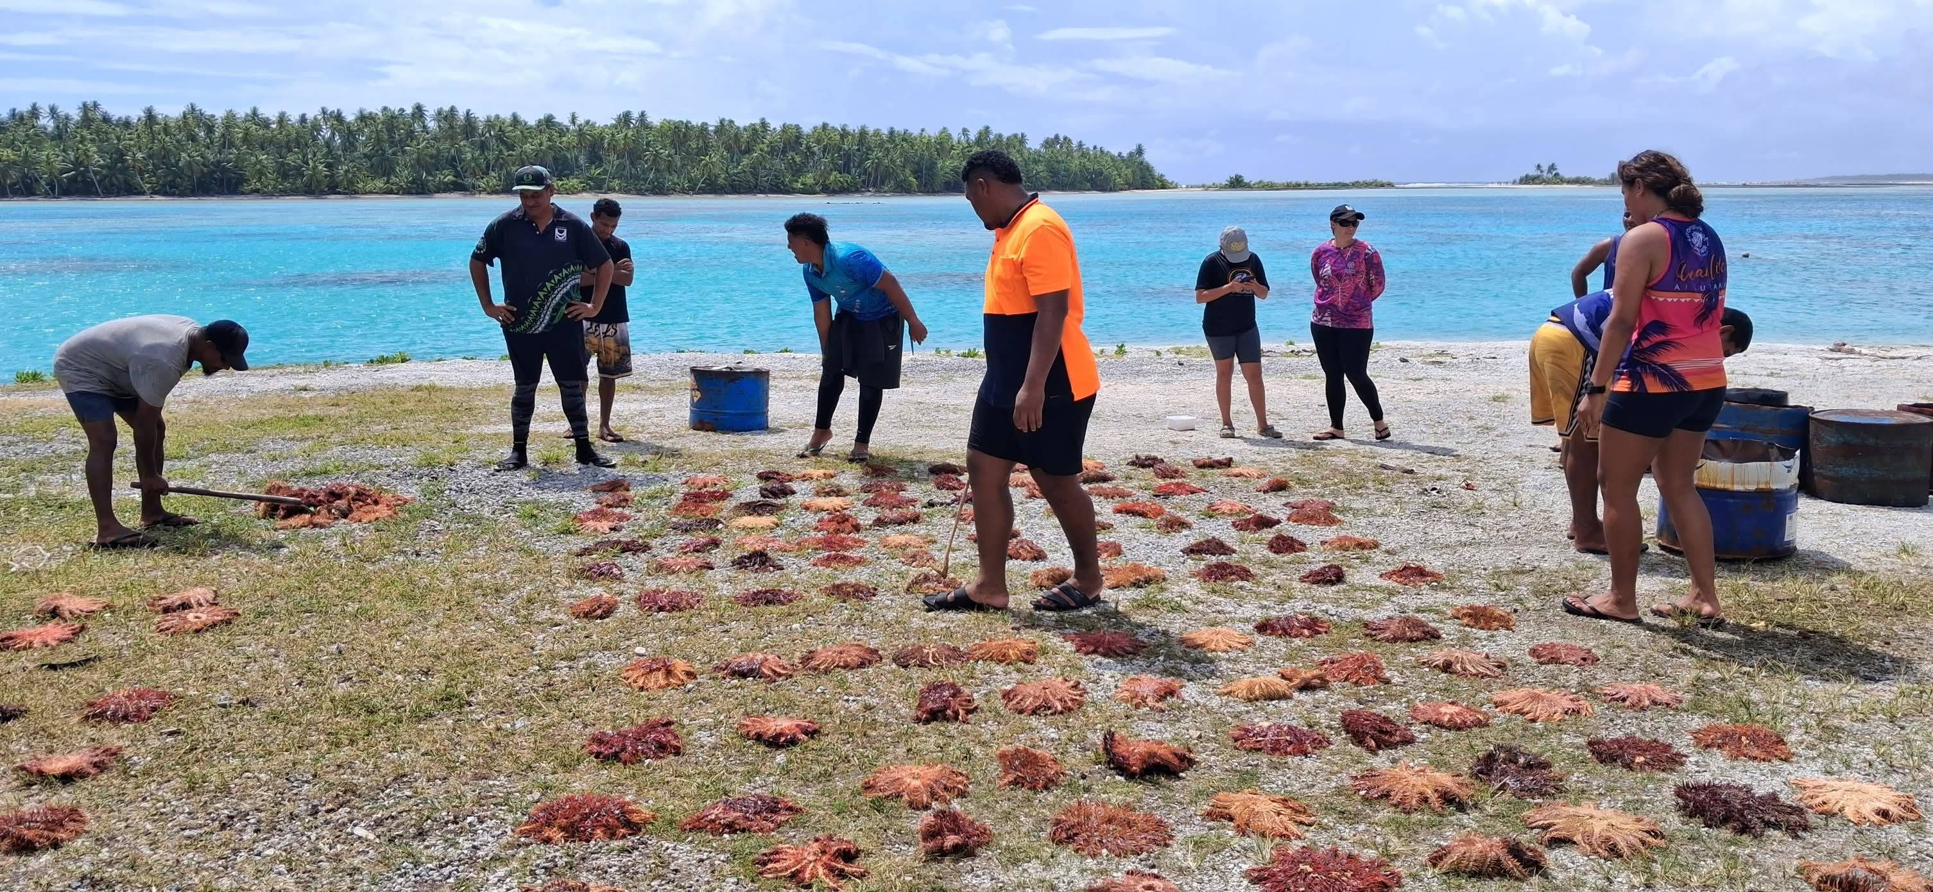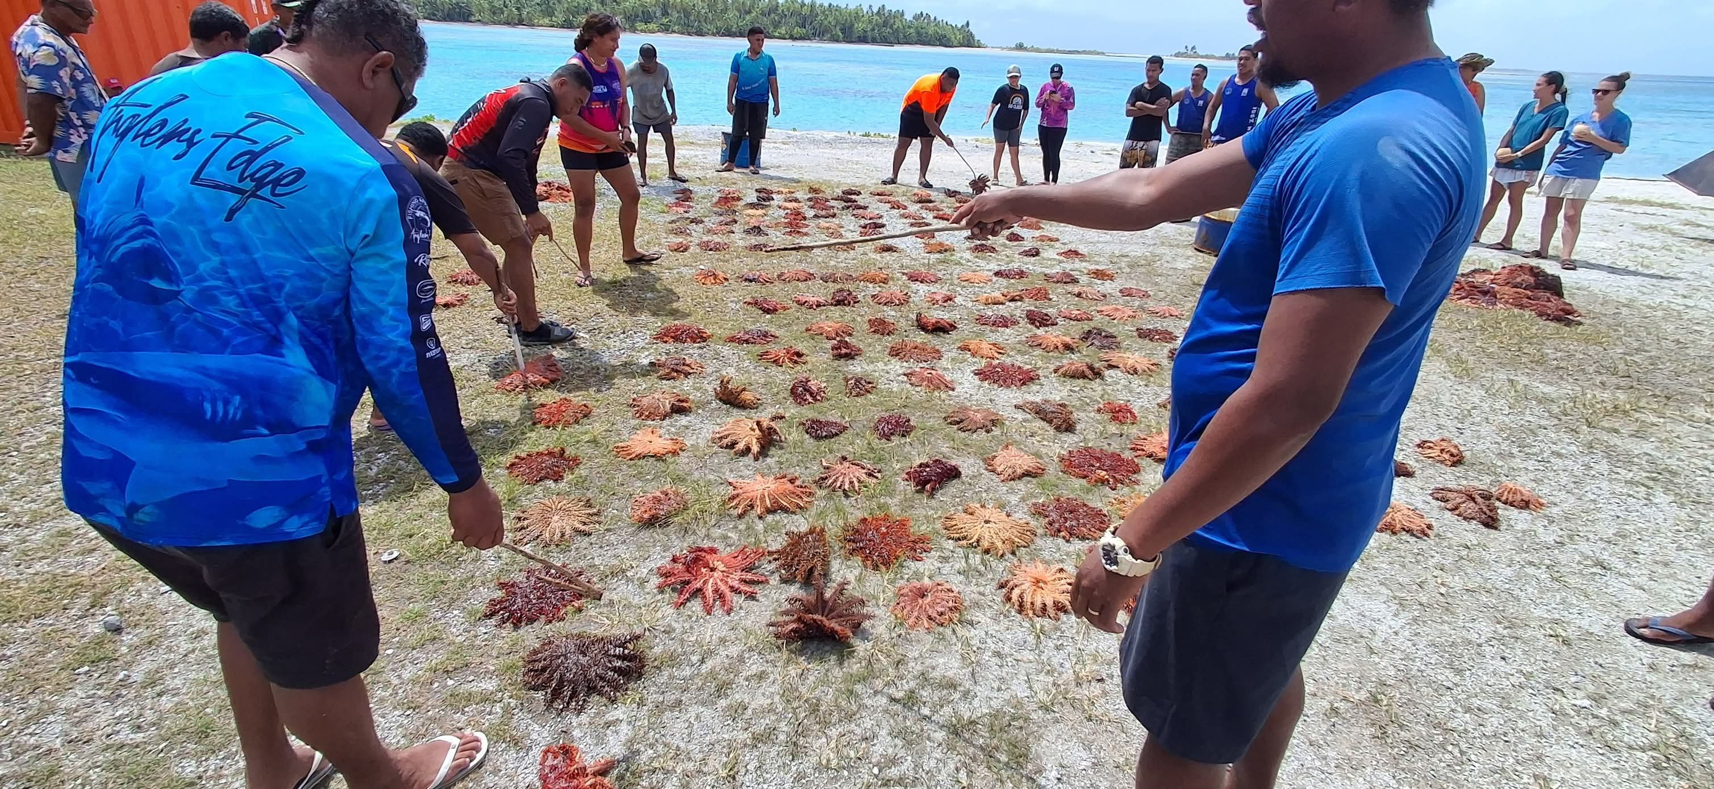

6. FEAST FOR THE ELDERLY, INFIRMED AND DISABLED

- This is now an annual event hosted only by Lima Malie and Amala Kula, two of the 4 TawaNgake Village guard groups called pule. The purpose of the feast is to show appreciation to the elderly for their years of service and contribution to the community at large. It also includes acknowledgement and recognition of our most vulnerable members within our Island Community, whom are often overlooked and sometimes forgotten.
- All recent visitors on the Island at the time were also invited to the feast as is our custom towards visitors or new arrivals.
- Food was also set aside and delivered personally to the infirmed and disabled whom were not able to attend the feast.
- Two birthdays were celebrated on the day of the feast. One was Minister Tingika Elikana’s and the other Mama Neria Paulo, widow of the last Paramount Chief or Aliki-wolo.

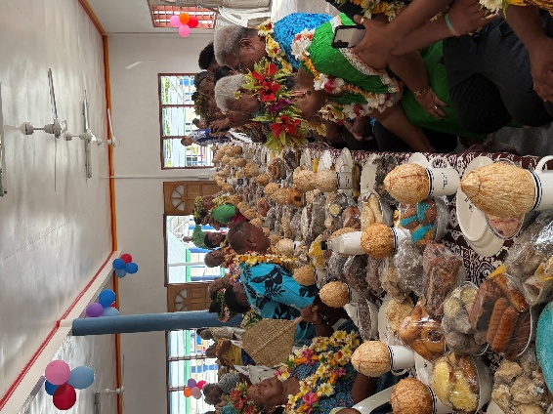
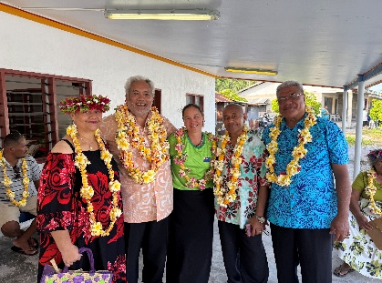
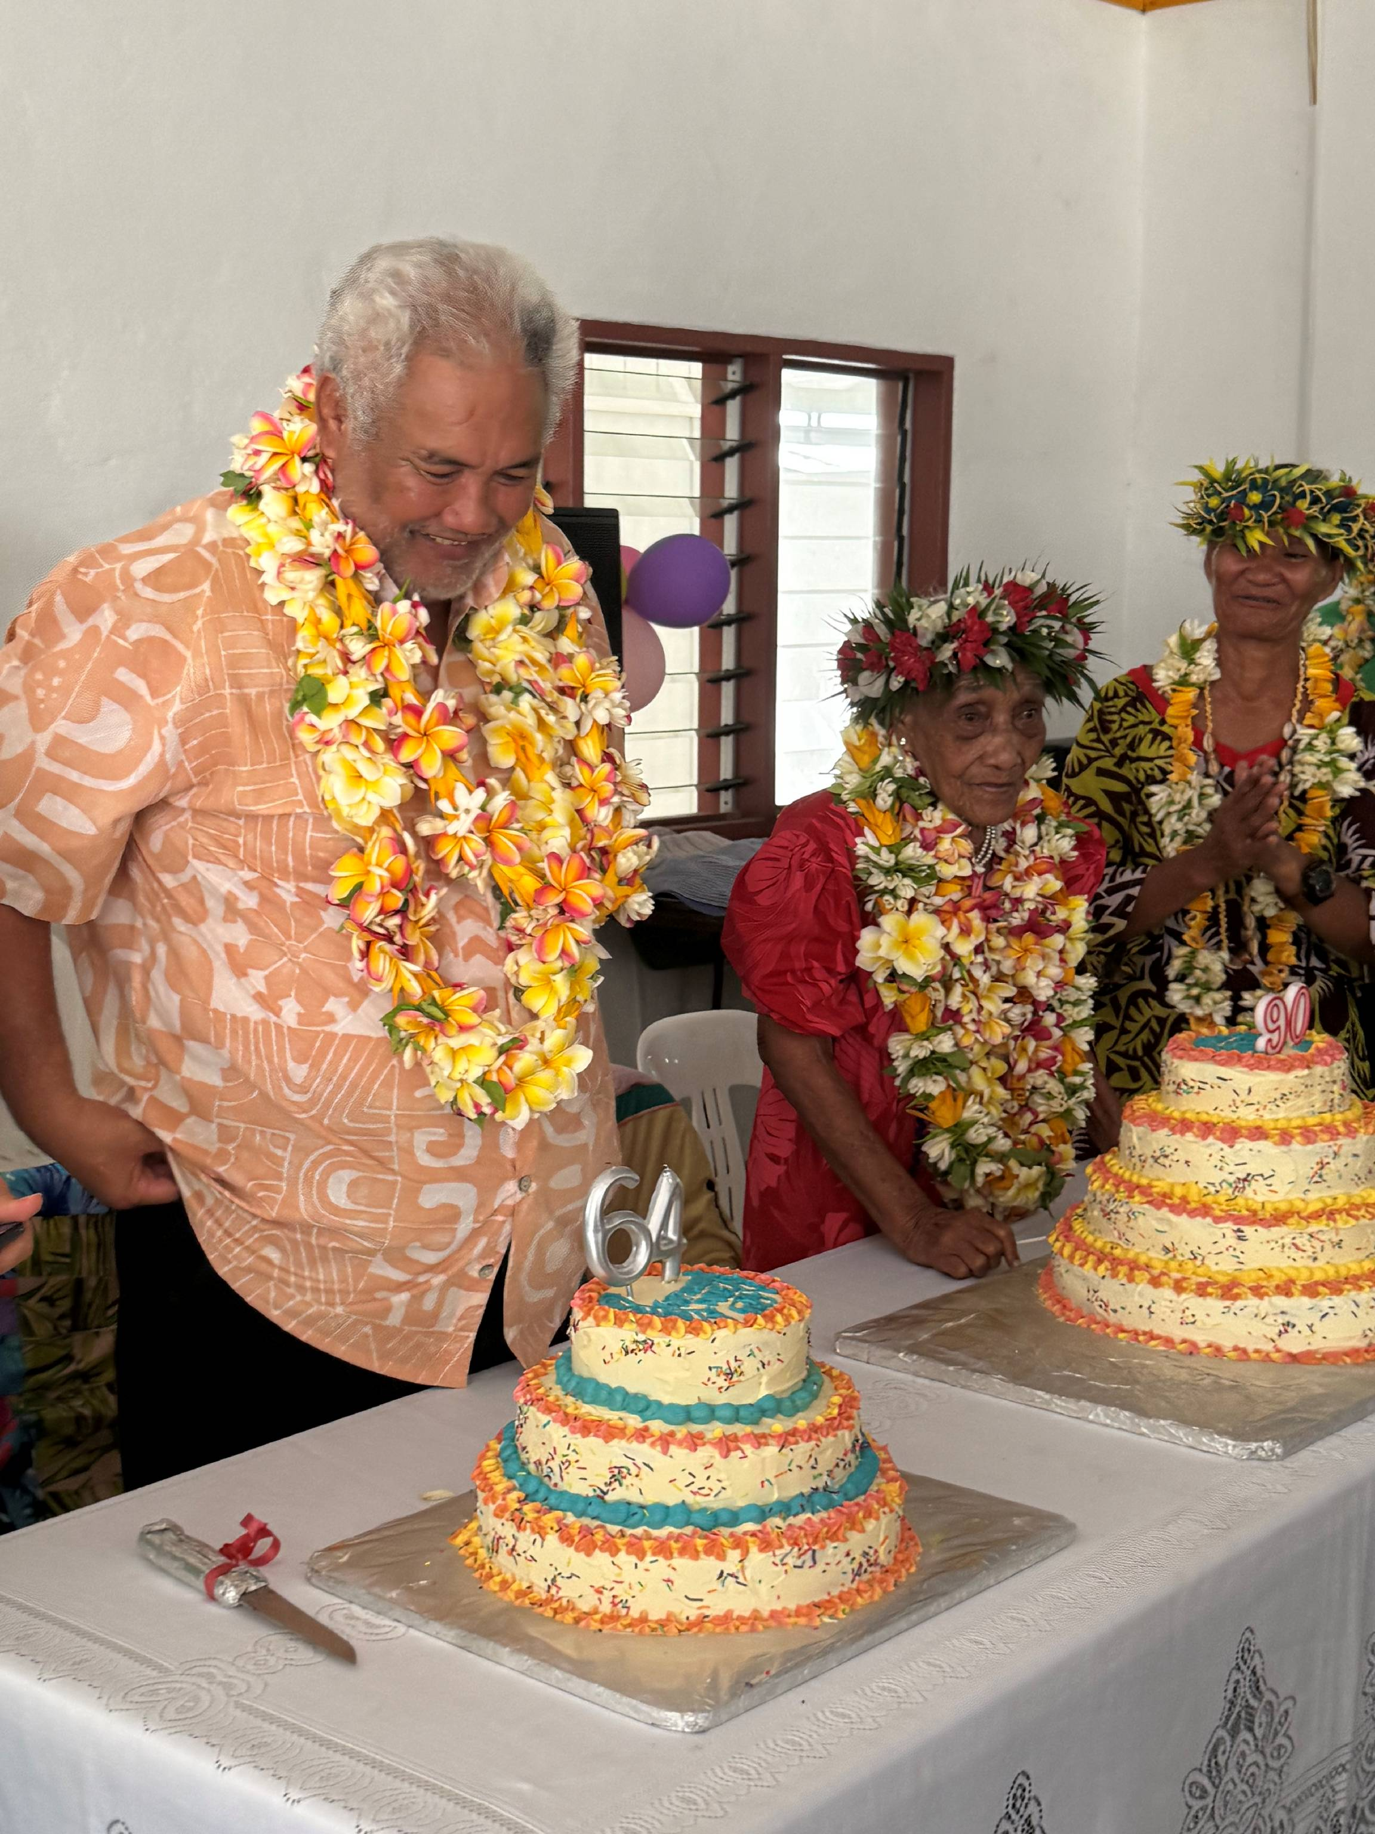

7. PUKAPUKA HYDROPONIC PROJECT - ON AGAIN

- The Pukapuka Hydroponics was a Climate Change Cook Islands project under the SRIC-CC program funded by the UNDP Adaptation Fund. Despite experiencing continued setbacks due to influences outside our control such as shipping delays and power outages.
- The hydroponic is not operational when there is no power supply to the water-pump and when seeds run out. But when seeds are finally available again and our power back to normal, we are able to enjoy vegetables such as lettuce and bok choy or Chinese cabbage and others in our diet once again. Although the cost of vegetables on the Island has doubled in price due to rising costs to resources, services and freight, our people are still lining up demanding more than we can supply.

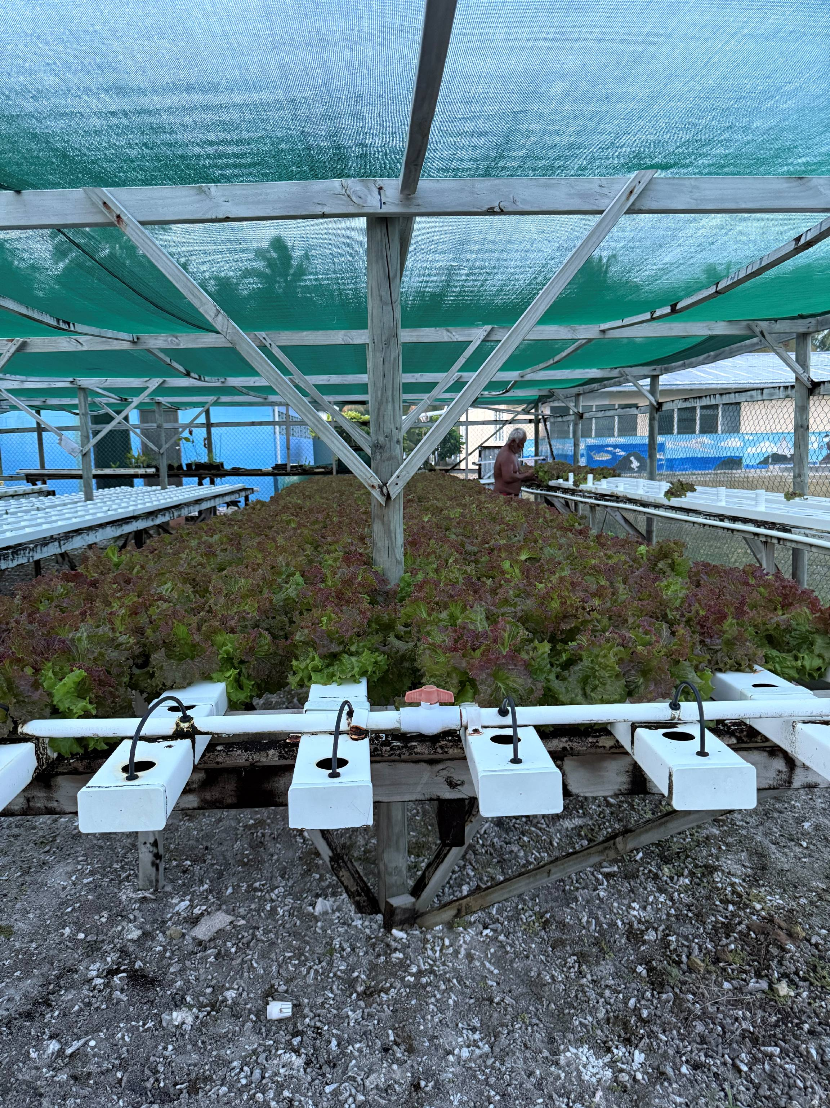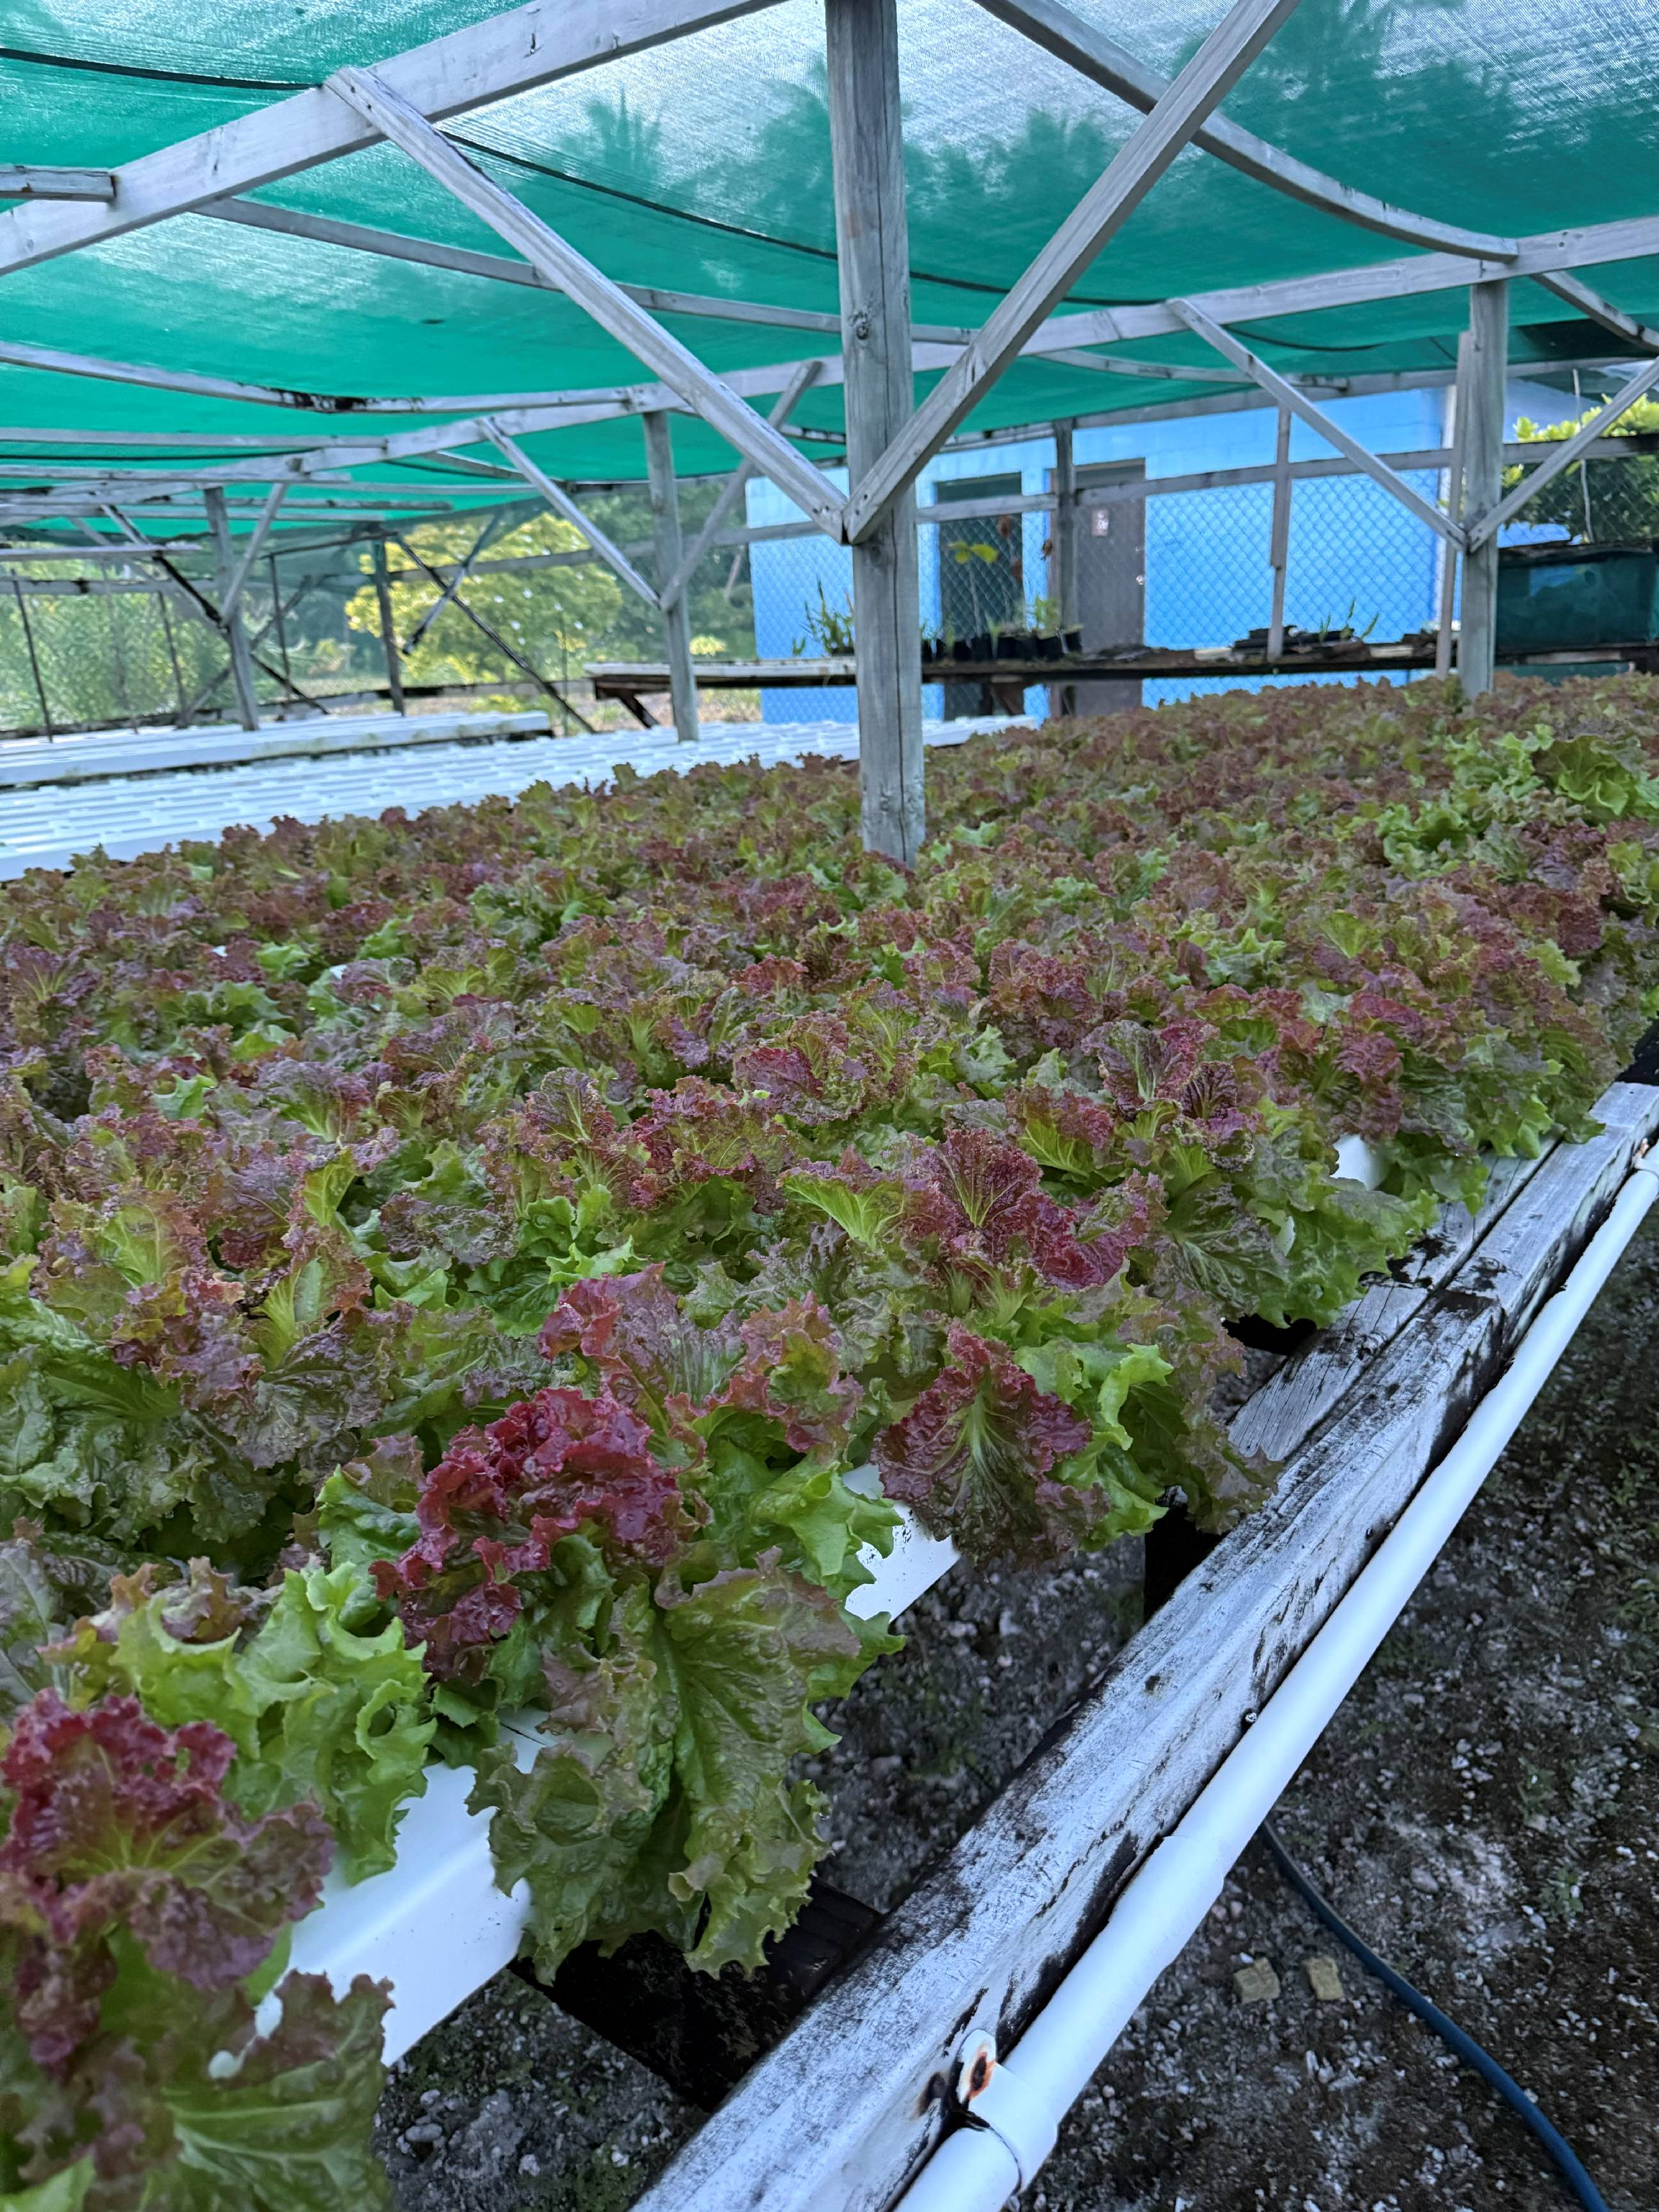
8. ROAD WORKS - OVERDUE

- Our Island Government and Administration is responsible for the maintenance and reparation of our Capital Buildings and Infrastructure works as part their routine maintenance program.
- Our summer season is also our wettest time of the year, clearly exposing pot holes and partial flooding to various areas of roadways. Sand and aggregate are obtained from within the lagoon near the beaches to fill these pot holes and flooded areas.

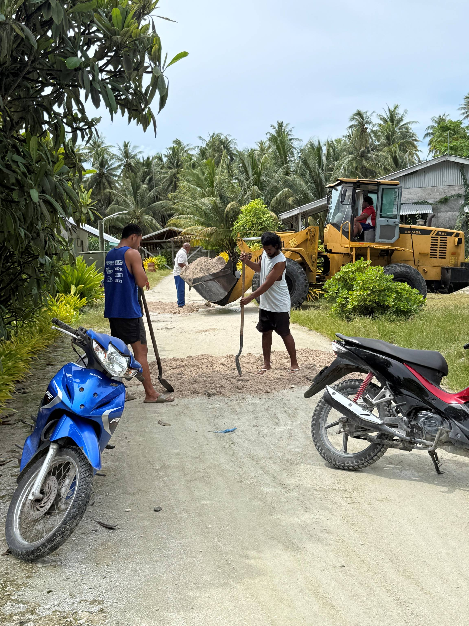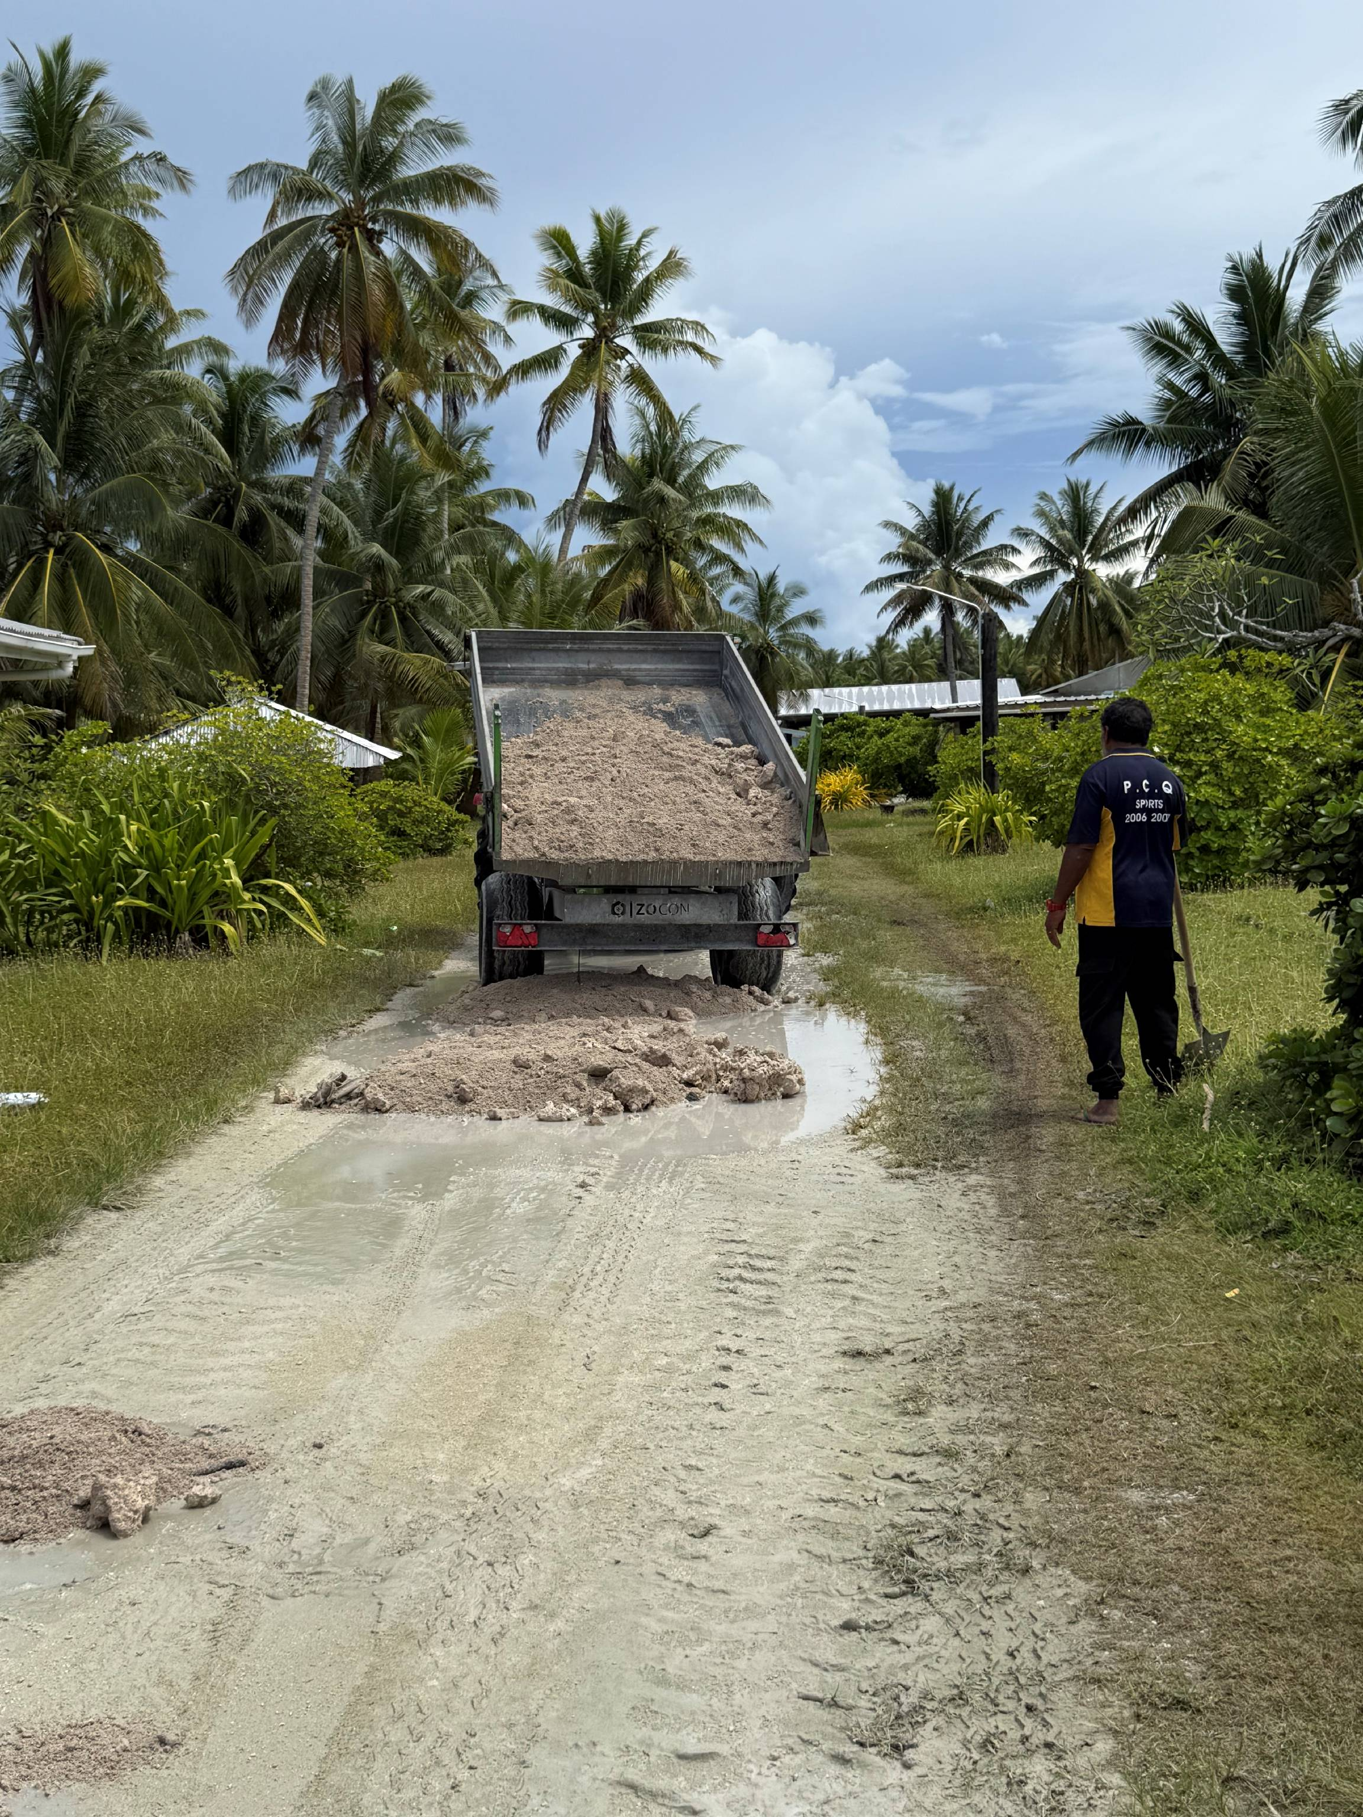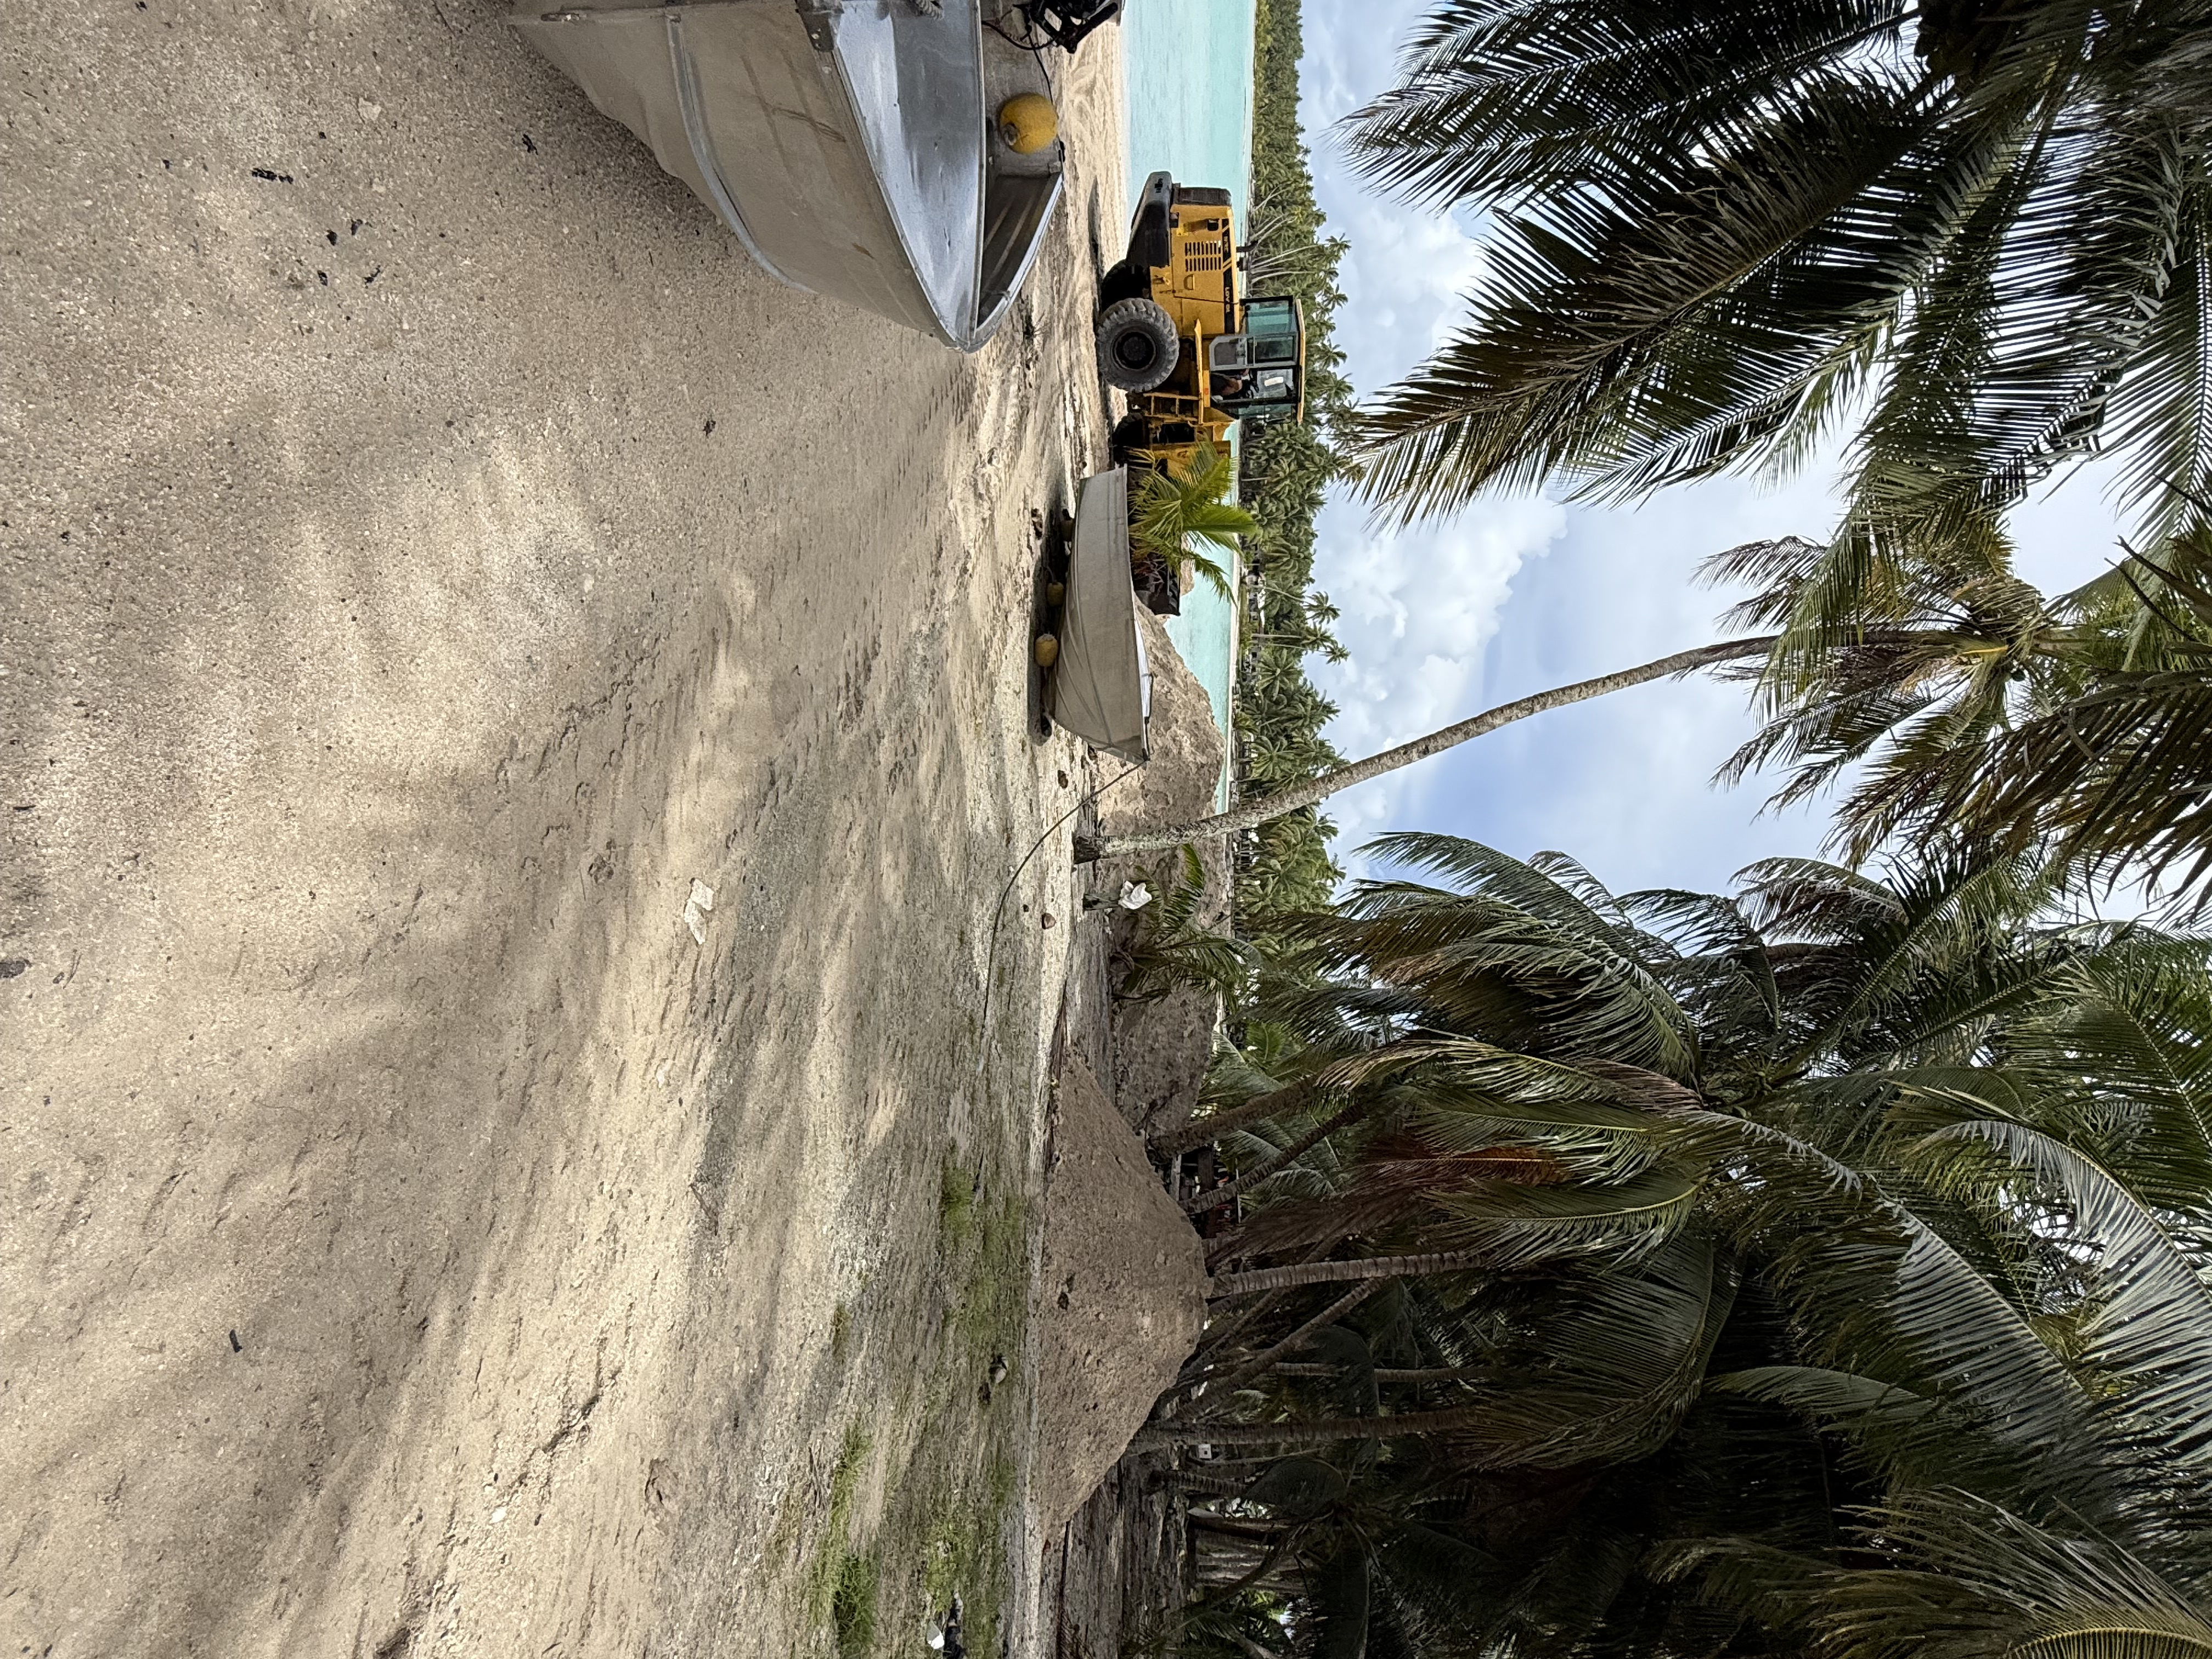

9. SOME OBVIOUS IMPACTS OF CLIMATE CHANGE

- Soil Erosion by wave action and seawater inundation caused by rising sea levels, prompting our people to start replanting programs along the shore lines.

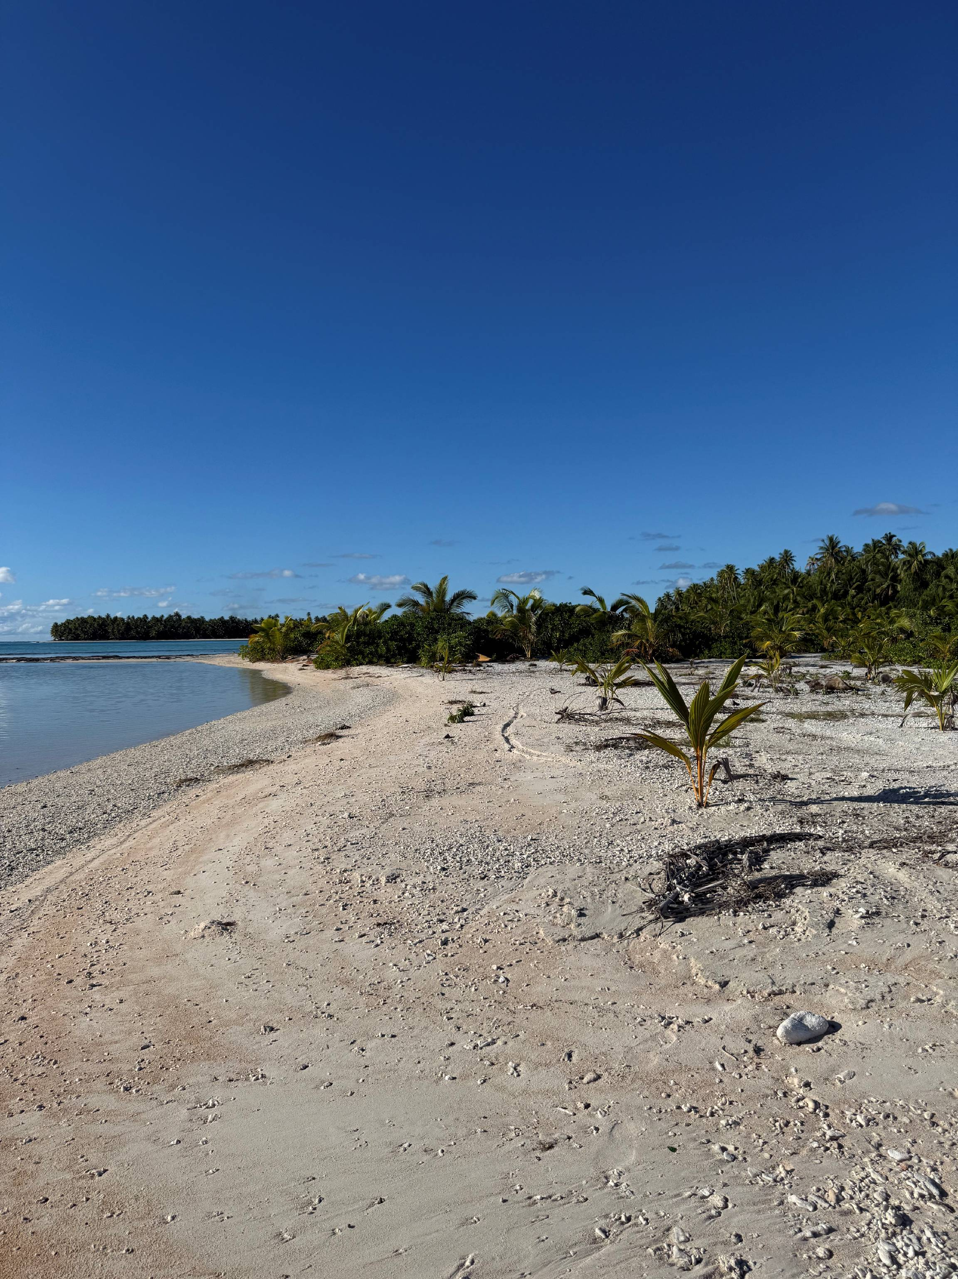

- Flora and Fauna Seasonal behaviors have seen some land crab (tupa and kaipea) species change their time of releasing their eggs from full moon to new moon.

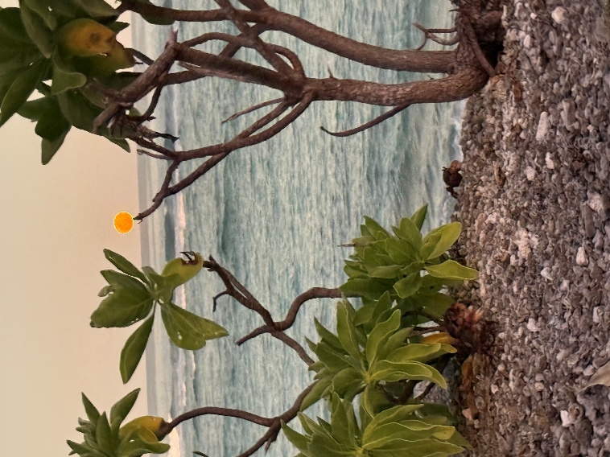

- Weather pattern changes such as frequency and severity of High Tides, Tropical Depressions and Cyclones, as well as high temperatures causing proliferation of some marine species such as crown-of-thorns starfish or taramea.

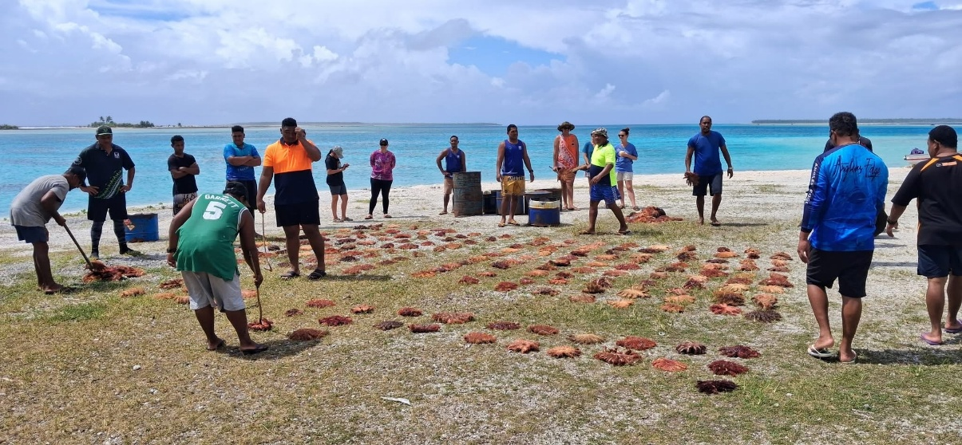

Report compiled by;

PATI RAVARUA
Pukapuka Island Facilitator

